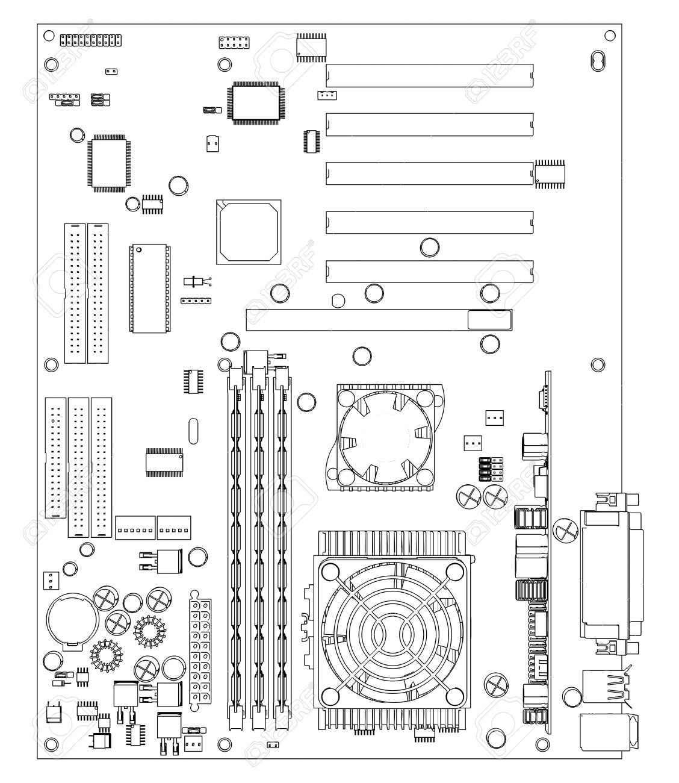**Label as many parts of the motherboard as you can.**

ROM?

Northbridge

Hard drive slots

CPU heat and fans

CPU socket

DRAM memory slots

Connectors for peripherals

Power connector

Southbridge

Backup Battery

AGP Slot

PCI Slots

PCI Slots

PCI Slots

PCI Slots

PCI Slots

**Spell your first name using the binary coding for ASCII and EBCDIC**

**ASCII –** *Example* A is 0100 0001 and a is 0110 0001

**M 0100 1101 A 0100 0001**

**i 0110 1001 m 0110 1101**

**c 0110 0011 o 0110 1111**

**h 0110 1000 o 0110 1111**

**a 0110 0001**

**e 0110 0101**

**l 0110 1100**

**EBCDIC –** *Example* A is 1100 0001 and a is 1000 0001

**M 1101 0100 A 1100 0001**

**i 1000 1001 m 1001 0100**

**c 1000 0011 o 1001 0110**

**h 1000 1000 o 1001 0110**

**a 1000 0001**

**e 1000 0101**

**l 1001 0011**